Flawless Academy
Flawless Academy offers programs for dance, vocals, and instruments. They are in need of a web application to customers to show their available packages and the estimated cost for it. Help them by developing an application
Create a Spring MVC Spring Boot Application for developing a flawless Academy Application. Design a enrollment page to choose an appropriate package ("ClassicalDance", "KarnaticVocals", "WesternDance", "Drawing", "Instruments") and enter the Number of sessions per week
On clicking program cost button, the application should calculate the program cost depending on the program chosen and the cost per session which the customers need to pay for the package The customer has to then be redirected to estimationPage.jsp page that displays the message "Welcome to Flawless Academy. Your preferred program cost is Rs. <<cost>>"
Application Work Flow:
- AcademyController is the Controller class.
- Academy is the model class with three attributes program, costPerSession, sessionsPerWeek and weeksPerMonth along with its getters and setters.
- AcademyService is the Service class which has a method called calculateProgramCost that takes Academy object as its argument and returns double.
- This method needs to set the costPerSession instance variable based on the cost per session (in Rs) value given in the below mentioned table.
- Calculate the program cost depending on the costPerSession for the program chosen and the sessionsPerWeek.
- By default the weeksPerMonth value should be 4.
- Program cost should be returned as double.
Program | Cost per session (in Rs)
ClassicalDance | 150.0
KarnaticVocals | 100.0
WesternDance | 125.0
Drawing | 130.0
Instruments | 200.0

Initially, the customer should be routed via the AcademyController's showPage method to enrollmentPage.jsp that allows user to choose the program and enter the sessionsPerWeek
[Note: showPage method has to be written inside the AcademyController]
A method in the AcademyController known as populatePrograms should be annotated with the ModelAttribute "programList". This method should populate the preferred programs (ClassicalDance, KarnaticVocals,WesternDance,Drawing,Instruments ) in the Map as key-value pair. Both key and value be the same program. (Example: Key- ClassicalDance, Value- ClassicalDance, Key- KarnaticVocals, Value- KarnaticVocals, etc) and then return the Map. This should be then used to auto-populate the program in the enrollmentPage.jsp
[Note: populatePrograms method should be written inside the AcademyController]
On clicking the program Cost button, the AcademyController's calculateProgramCost method should be called. This method takes three arguments - model attribute named "academyBean" which holds the form populated Academy Object, BindingResult and the ModelMap. This method should call the calculateProgramCost method in the AcademyService class, where we calculate the program cost.
Calculation of program cost:
If the preferred program is "Drawing" and sessionsPerWeek is 3.
program cost= sessionsPerWeek* costPerSession * weeksPerMonth (by default weeksPerMonth is 4)
program cost= 3 * 130.0 * 4 => 1560.0
If the sessionsPerWeek entered by the customer is less than 2 then an error message "Minimum 2 Sessions/Week" has to be displayed in the enrollmentPage.jsp. If the sessionsPerWeek entered by the customer is greater than 5 then an error message "Maximum 5 Sessions/Week" has to be displayed in the enrollmentPage.jsp To do this validation use appropriate annotation above sessionsPerWeek attribute in Academy model class.
Note : Perform the above Validations using annotations that are available in jakarta.validation.constraints package.
Screen designs and Expected Output:
enrollmentPage.jsp

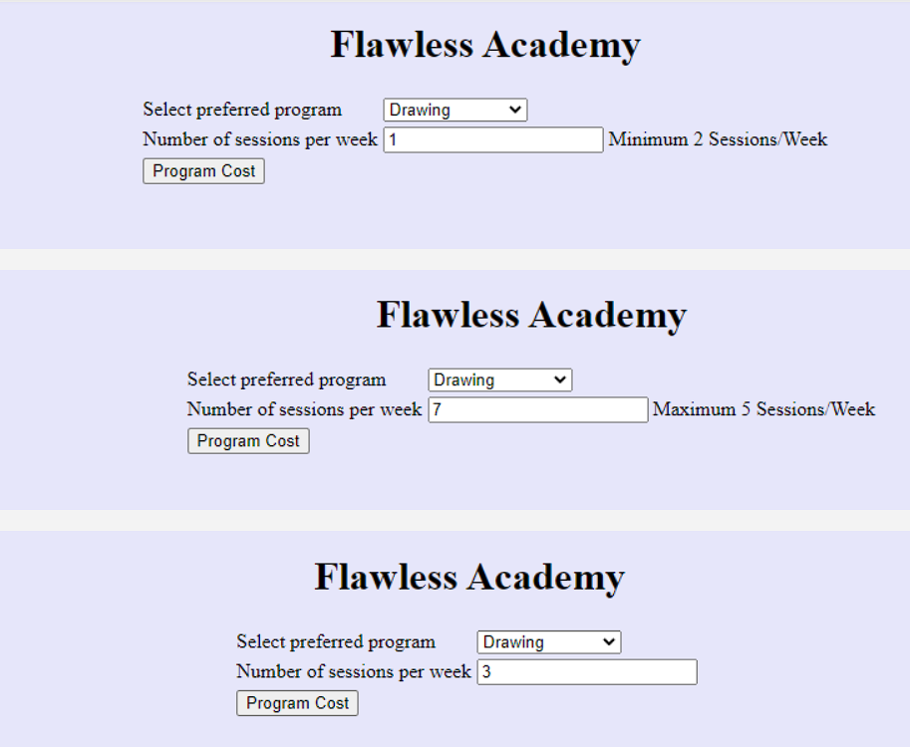

- Redirect the user to estimationPage.jsp page with a message "Welcome to Flawless Academy. Your preferred program cost is Rs. << cost>>"

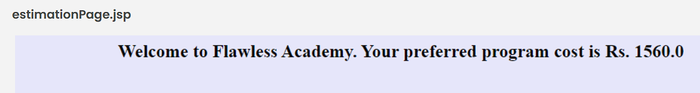

Design Constraints:
UI Design Constraints:
enrollmentPage.jsp
Component | ID | Constraints
Select | program | Should be auto-populated using the model attribute written above the populatePrograms method inside the AcademyController. Do not hard code the values
Textbox | sessionsPerWeek | Should not be less than 2 and should not be greater than 5
submit | submit | Name and id attribute should be submit -
Note:
- In estimationPage.jsp, the Result has to be rendered in the <h2> tag
- In the sessionsPerWeek text box, use the id "errormsg" to display the error message.
Component Specification
Controller
AcademyController
AttributeName | AttributeType | Access Specifier | Constraints
service | AcademyService | private | Use annotation to Autowire

AcademyController
Method Name | Method Argument name:type | Return type | RequestMapping URL & Request Method
showPage | modelAttribute "academyBean": Academy | String | /enrollmentPage & GET
calculateProgramCost | modelAttribute "academyBean":Academy, result:BindingResult, model:ModelMap | String | /progEstimation & POST
populatePrograms |  | Map <String,String> | Should be annotated with ModelAttribute with name "programList"

Service:
AcademyService
Method Name | Method Argument name:type | Return type
calculateProgramCost | academyBean:Academy | double

Model:
Academy
AttributeName | AttributeType
program | String
costPerSession | double
sessionsPerWeek | int
Note: The variable weeksPerMonth has already been assigned a value of 4.
Overall Design Constraints:
- AcademyController should be inside the package com.controller
- AcademyService should be inside the package com.service
- Academy should be in the package com.model
- Use appropriate annotation to configure AcademyService as a Service
- Use appropriate annotation to configure AcademyController as a Controller
- AcademyService should be autowired inside the AcademyController.
- Use annotations to implement the business Validation as specified in the screenshot [That is when the sessionsPerWeek is less than 2 then error message "Minimum 2 Sessions/Week" and when sessionsPerWeek greater than 5 then error message "Maximum 5 Sessions/Week" should be rendered in the UI.]
- Do not change the property name given in the application.properties files, you can change the value and you can include additional property if needed.
- In the pom.xml you are provided with all the dependencies needed for developing the application.
- You will not be evaluated based on the UI design (layout, color, formatting, etc.). You are free to have a basic UI with all the required UI components (input fields, buttons, labels, etc.). Expected components with the id alone should be designed as per the requirement.
- Adhere to the design specifications mentioned in the case study.
- Do not change or delete the class/method names or return types that are provided to you as a part of the base code skeleton.
- Please make sure that your code does not have any compilation errors while submitting your case study solution.

Delivery Agency
Delivery Agency is a web application to track the delivery details of an order. Along with that they need to search the delivered and pending orders on a particular date. Help them by developing an application
Create a Spring MVC Spring Boot Application for developing a Delivery Agency Application. Design a search page for finding delivered and pending orders based on date and delivery status.
On clicking search button, the application should list the order based on the given search criteria. Then the control has to be redirected to deliveryListPage.jsp page that displays the list of orders in tabular format
Application Work Flow:
- AgencyController is the Controller class.
- Order is the model class with attributes and its getters and setters.
- AgencyService is the Service class that has a method called searchDeliveryOrders that takes Order as its argument and returns ArrayList<Order>.
- Attribute ArrayList<Order> list; defined in the service class. And the value for this list was populated through addOrders method. Don't change the code in this method.
- Through searchDeliveryOrders method, have to search the Order objects based on the given input delivery date and status. (Iterate the list, get the Order objects which have the same date and status entered in UI)
Initially, the searchPage.jsp should be routed via the AgencyController's searchPage method ,that allows user to enter the delivery date and status.
[Note: searchPage method has to be written inside the AgencyController]
In AgencyService you are provided with a method addOrders which populates the list attribute with few Order objects.
On clicking the search button, the AgencyController's searchDeliveryOrders method should be called. This method takes three arguments - model attribute named "orderBean" which holds the form populated Order Object, BindingResult and the ModelMap. This method should call the searchDeliveryOrders method in the AgencyService class, where we list the order details based on the delivery date and status
Screen designs and Expected Output:

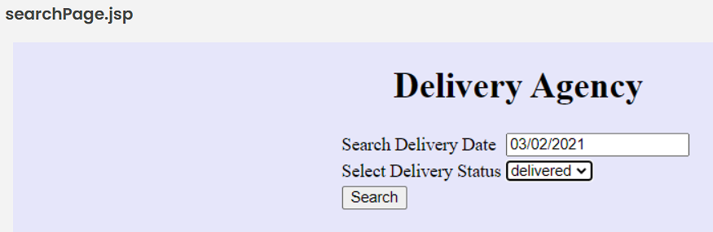

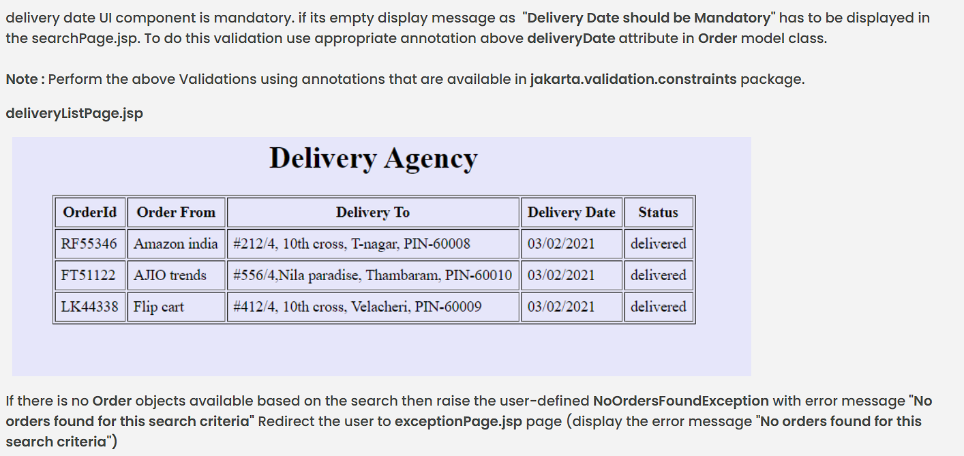

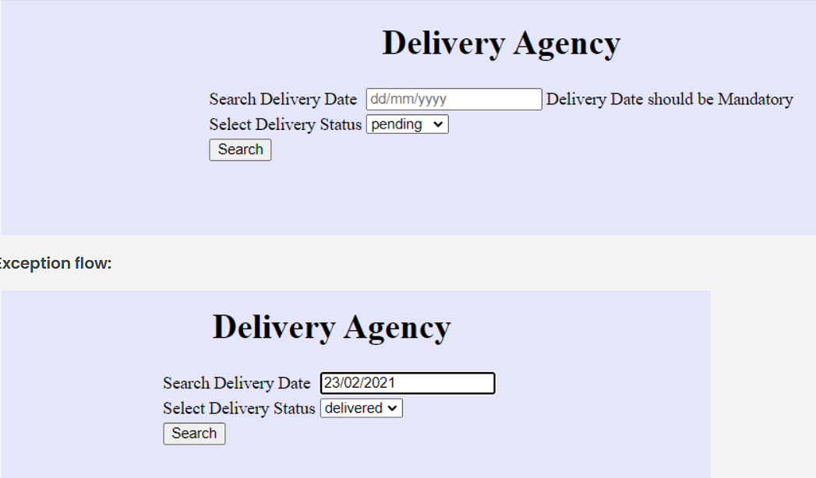

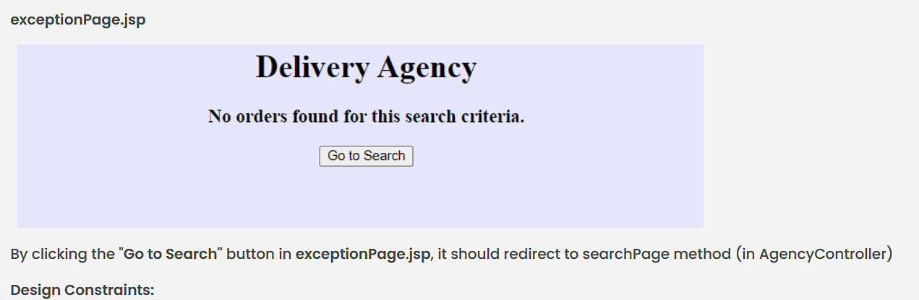

Design Constraints:
UI Design Constraints:
searchPage.jsp
Component | ID | Constraints
Textbox | deliveryDate | Name and id attribute should be deliveryDate, Default placeholder value should be "dd/mm/yyyy"
Drop down | deliveryStatus | Name and id attribute should be deliveryStatus. Populate the values as "delivered" and "pending"
submit | submit | Name and id attribute should be submit
Note : In the deliveryDate text box, use the id "errormsg" to display the error message.
Component Specification
Controller
AgencyController
AttributeName | AttributeType | Access Specifier | Constraints
service | AgencyService | private | Use annotation to Autowire

AgencyController
Method Name | Method Argument name:type | Return type | RequestMapping URL & Request Method
searchPage | modelAttribute "orderBean":Order | String | /searchPage & GET
searchDeliveryOrders | modelAttribute "orderBean":Order, result:BindingResult, model:ModelMap | String | /orderList & POST
exceptionHandler | Exception exception | ModelAndView | Use appropriate annotation to handle the exception
Service:
AgencyService
Method Name | Method Argument name:type | Return type
searchDeliveryOrders | orderBean:Order | ArrayList<Order>

Model:
OrderBean
AttributeName | AttributeType
orderId | String
orderFrom | String
deliveryTo | String
deliveryDate | String
deliveryStatus | String
Overall Design Constraints:
- AgencyController should be inside the package com.controller
- AgencyService should be inside the package com.service
- Order should be in the package com.model
- NoOrdersFoundException class should in package com.exception.
- Use appropriate annotation to configure AgencyService as a Service
- Use appropriate annotation to configure AgencyController as a Controller
- AgencyService should be autowired inside the AgencyController.
- Use appropriate annotation to handle Exceptions in AgencyController class.
- Use annotations to implement the business Validation as specified in the screenshot [That is when the deliveryDate is empty then error message "Delivery Date should be Mandatory" should be rendered in the UI.]
- In the pom.xml you are provided with all the dependencies needed for developing the application.
- Do not change the property name given in the application.properties files, you can change the value and you can include additional property if needed.
- You will not be evaluated based on the UI design (layout, color, formatting, etc.). You are free to have a basic UI with all the required UI components (input fields, buttons, labels, etc.). Expected components with the id alone should be designed as per the requirement.
- Adhere to the design specifications mentioned in the case study.
- Do not change or delete the class/method names or return types that are provided to you as a part of the base code skeleton.
- Please make sure that your code does not have any compilation errors while submitting your case study solution.

